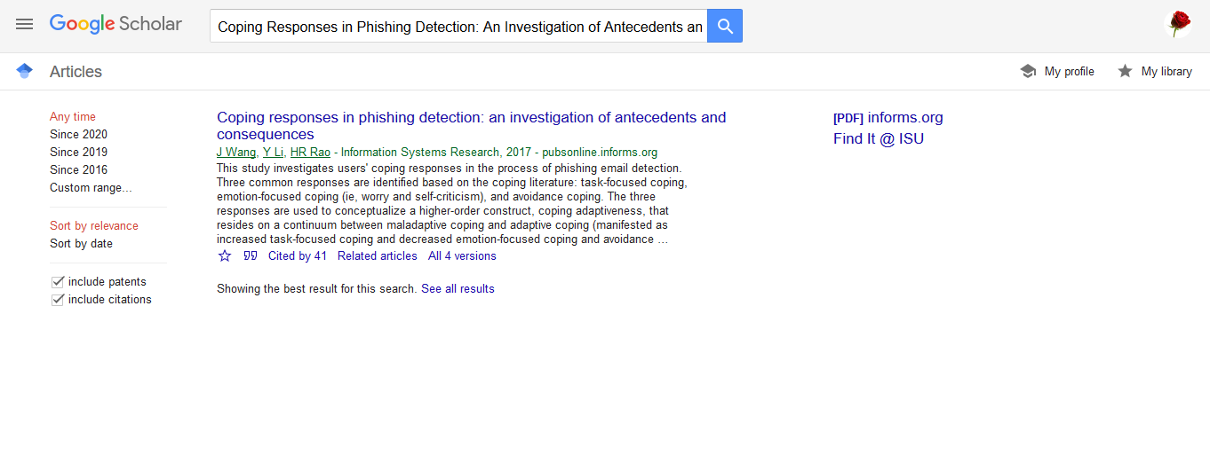

**The APA citation**

Wang, J., Li, Y., & Rao, H. R. (2017). Coping responses in phishing detection: an investigation of antecedents and consequences. *Information Systems Research*, *28*(2), 378-396.